**Assignment 3**

**Write a program to input a single character and print a message &quot;its a vowel&quot; if it is a vowel**

**otherwise print &quot;its a consonant&quot;.**

**Use switch statement.**

**SOURCE CODE**

#include <iostream>

using namespace std;

int main()

{

char x;

cout<<"Enter a letter \n";

cin>>x;

cout<<" "<<endl;

switch(x){

case 'a':

cout<<x<<" is a vowel"<<endl;

break;

case 'e':

cout<<x<<" is a vowel"<<endl;

break;

case 'i':

cout<<x<<" is a vowel"<<endl;

break;

case 'o':

cout<<x<<" is a vowel"<<endl;

break;

case 'u':

cout<<x<<" is a vowel"<<endl;

break;

default:

cout<<x<<" is a consonant"<<endl;

break;

}

return 0;

}

**OUTPUT**

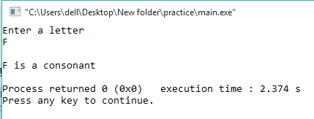 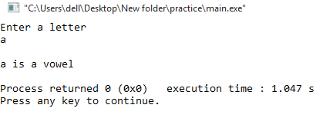

**Question#02**

**Write a program to input marks obtained by a student in a subject. The total marks are 100.**

**Find out the grades of the student by using the if else neseted structure. The grades are:**

**if marks are equal to or greater than 90, grade is A+**

**if marks are equal to or greater than 70 and less than 90, grade is A**

**if marks are equal to or greater than 50 and less than 70, grade is B**

**if marks are less than 50, grade is F**

**SOURCE CODE**

#include <iostream>

using namespace std;

int main ()

{

int a;

cout<<"Enter marks of 1st subject"<<endl;

cin>>a;

if (a>=90&&a<=100)

cout<<"Student has been awarded A+ grade"<<endl;

else if (a>=70&&a<90)

cout<<"Student has been awarded A grade"<<endl;

else if (a>=50&&a<70)

cout<<"Student has been awarded B grade"<<endl;

else if (a<50)

cout<<"Student has been awarded F grade"<<endl;

return 0;

}

**OUTPUT**

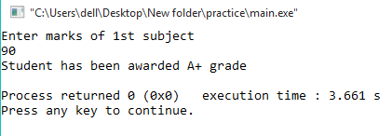

**Question#03**

**Write a program to input four integers. Find out the largest value and print it on the screen**

**using nested if else and logical operator.**

**SOURCE CODE**

#include <iostream>

using namespace std;

int main ()

{

int a,b,c,d;

cout<<"Enter four integers "<<endl;

cin>>a>>b>>c>>d;

if(a>b&&a>c&&a>d)

cout<<a<<" is the largest value"<<endl;

else if(b>a&&b>c&&b>d)

cout<<b<<" is the largest value"<<endl;

else if(c>a&&c>b&&c>d)

cout<<c<<" is the largest value"<<endl;

else if(d>a&&d>b&&d>c)

cout<<d<<" is the largest value"<<endl;

return 0;

}

**OUTPUT**

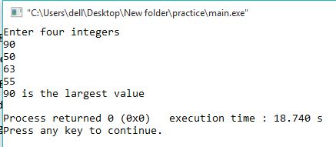

**Question #04**

**Write a program using different logical operators together using the following scenario:**

**{Note: You have to take gender “F”|”M” that must be stored in character variable, age and City**

**name as K|H|S|G as Karachi, Hyderabad, Sukker and GHotki that must be stored in character**

**variable.**

**1) If gender is female, age is between 25-35 and from Karachi or Hyderabad, add 2000 in**

**the salary and print the net salary.**

**2) If gender is male, age is between 25-40 and from Sukker or Ghotki, add 2500 in the**

**salary and print the net salary.**

**3) Otherwise print the present salary no any addition.**

**SOURCE CODE**

#include <iostream>

using namespace std;

int main ()

{

char a,c;

int netsalary, b;

cout<<"Enter gender M/F"<<endl;

cin>>a;

cout<<"Enter age 25-40 "<<endl;

cin>>b;

cout<<"Enter city \nMALE \nK for Karachi H for Hyderabad \nFEMALE\nS for Sukker G for Ghotki"<<endl;

cin>>c;

netsalary=0;

if(a=='F'&&b>=25&&b<=35&&c=='K'||c=='H')

{

netsalary+=2000;

cout<<"Net salary is "<<netsalary<<endl;

}

else if (a=='M'&&b>=25&&b<=40&&c=='S'||c=='G')

{

netsalary+=2500;

cout<<"Net salary is "<<netsalary<<endl;

}

else

cout<<"Present salary with no addition is "<<netsalary<<endl;

return 0;

**}**

**OUTPUT**

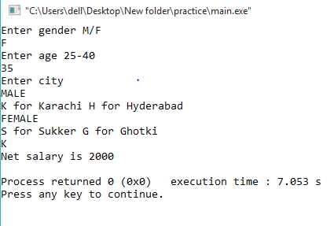

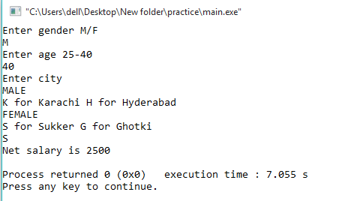

**Question #05**

**Using the “goto” statement generate the table of 3. Do not use any iteration**

**(looping) statement.**

**SOURCE CODE**

**#**include <iostream>

using namespace std;

int main ()

{

int a,b=0,c;

cout<<"Enter table number "<<endl;

cin>>a;

doagains:

++b;

c=a*b;

cout<<a<<" * "<<b<<" = "<<c<<endl;

if(b<12)

goto doagains;

return 0;

}

**OUTPUT**

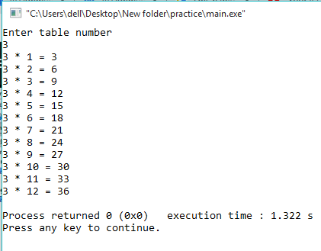

**Question#06**

**Write a program in C++ to find the sum of first 10 natural numbers. Go to the**

**editor**

**Sample Output:**

**Find the first 10 natural numbers:**

**---------------------------------------**

**The natural numbers are:**

**1 2 3 4 5 6 7 8 9 10**

**The sum of first 10 natural numbers: 55**

**SOURCE CODE**

#include <iostream>

using namespace std;

int main ()

{

int b=1,c=0;

cout<<"The natural numbers are "<<endl;

doagains:

cout<<b;

++b;

c+=b;

if(b<=10)

goto doagains;

else

cout<<"\nThe sum of the first 10 natural numbers :"<<c<<endl;

return 0;

}

**OUTPUT**

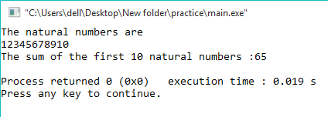

**Question#07**

**Write a program to calculate the sum of all odd numbers from 5 to 50 and then print the sum of**

**on the screen.**

**SOURCE CODE**

#include <iostream>

using namespace std;

int main ()

{

int a=0;

for(int i=5; i<=50;i++,i++)

{

a+=i;

}

cout<<"the sum of all odd numbers from 5 to 50 is "<<a<<endl;

return 0;

}

**OUTPUT**

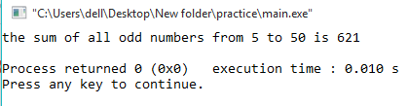

**Question#08**

**Using the multivariable in single for loop generate the following output:**

**SOURCE CODE**

#include <iostream>

using namespace std;

int main ()

{

int a=105,b=0,c=22,d=600;

for(int i=1; i<=5;i++)

{

a-=5;

cout<<a<<"\t";

b+=1;

cout<<i<<"\t";

c-=2;

cout<<c<<"\t";

d-=100;

cout<<d<<endl;

}

return 0;

}

**OUTPUT**

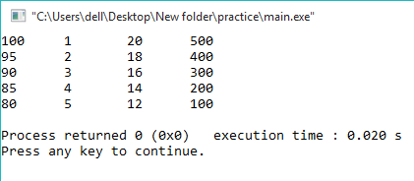

**Question#09**

**12. Write a program in C++ to calculate the sum of the series (1*1) + (2*2) + (3*3) + (.(n*n).**

**Sample Output:**

**Input the value for nth term: 5**

**1*1 = 1**

**2*2 = 4**

**3*3 = 9**

**4*4 = 16**

**The sum of the above series is: 55**

**SOURCE CODE**

#include <iostream>

using namespace std;

int main ()

{

int a,b=1,c=0;

cout<<"Enter a number "<<endl;

cin>>a;

for(int i=1; i<=a;i++,b++)

{

b=i*i;

cout<<i<<" * "<<i<<" = "<<b<<endl;

c=c+b;

}

cout<<"The sum of the abouve series is "<<c<<endl;

return 0;

}

**OUTPUT**

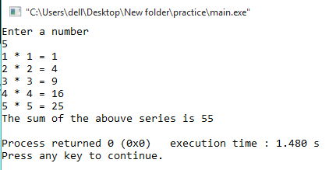

**Question#10**

**A program that takes input of two numbers from user as a starting and ending then prints all even**

**numbers between them.**

**Output:**

**Enter starting number: 7**

**Enter ending number: 25**

**Even numbers between 7 and 15 are**

**8, 10, 12, 14, 16, 18, 20, 22, 24**

**SOURCE CODE**

#include <iostream>

using namespace std;

int main ()

{

int a,b;

cout<<"Enter starting number "<<endl;

cin>>a;

cout<<"Enter ending number "<<endl;

cin>>b;

cout<<"Even numbers between "<<a<<" and "<<b<<" are"<<endl;

for(a; a<=b;a++)

{

if(a%2==0)

{

cout<<a<<",";

}

}

return 0;

}

**OUTPUT**

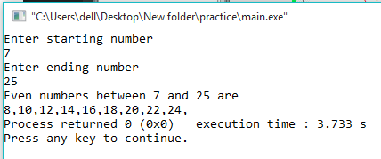

**Question#11**

**Generate the following out using nested for loop.**

**1**

**1 2**

**1 2 3**

**1 2 3 4**

**SOURCE CODE**

#include <iostream>

using namespace std;

int main ()

{

for(int i=1;i<=4;i++)

{

for(int k=1;k<i;k++)

{

cout<<k;

}

cout<<i<<endl;

}

return 0;

}

**OUTPUT**

